APPENDIX A – Details of the Marking Scheme

A.1 Marking Scheme:

Type of Publication/Patent |  | Any author category
(1a) | Full-paper is refereed and published in (a) Q1 or Q2 journals¹ indexed in Scopus, and/or in SCIE, SSCI, AHCI and ESCI, or (b) journals or conferences in top 20 sources in sub-categories² of Google Scholar Metrics.  (See Note 2, and Note 7) | 4.5
(1b) | Full-paper is refereed and published in journals indexed in Scopus, and/or in SCIE, SSCI, AHCI and ESCI but not Q1 or Q2.  (See Note 2, and Note 7) | 4.5
(2) | Full-paper is refereed and published in (a) conferences, book chapters, and books indexed in Scopus, or (b) credible peer-reviewed journals³ but not in any indexes/databases identified in (1) above.  (See Note 2, and Note 7) | 3.0
(3) | Full-paper is refereed and published in (a) international conferences, or (b) transactions of recognized professional associations, but not in any indexes/databases identified in (1) above.  (See Note 7, and Note 8) | 2.5
(4) | Full-paper is refereed and published in national conferences but not in any indexes/databases identified in (1) above.  (See Note 7, and Note 8) | 1.5
(5) | Patents supported each by a peer reviewed published paper which demonstrates the technology/methodology that resulted in the innovation (See Note 5) | 3.0
(6) | Patents (See Note 5) | 1.5
¹ Evidence for being Q1 or Q2 can be obtained from the website https://www.scimagojr.com/
Please refer to Annex 2 of Appendix A
² These subcategories should be the ones pre-defined in Google Scholar Metrics; e.g. the main category “Engineering & Computer Science” has 68 sub-categories, each of which lists 20 top sources.
³ Credibility of journals will be judged by the Evaluation Panel. Please refer to Note 7 (c).

A.2 Qualifying Requirement:

Awards are based on marks obtained for a single year.

- All the permanent Academic Staff; and Assistant Librarian and above are eligible to apply for the awards.
- Only publications with the University of Moratuwa affiliation, and the official UoM email address (if email addresses are published of the applicant) will be considered for awards.
- Each application will be judged for one of the two categories of awards or a certificate of recognition. Rounding up will be considered up to maximum of 0.5 marks.
- Applicants are not ranked based on marks they obtain. To qualify for an award obtaining minimum marks specified for each category is sufficient.

Category 1 - Outstanding Award with Distinction
A minimum of 7.5 marks in total with a minimum of 4.5 marks from “Type 1a” publications.

Category 2 - Outstanding Award
A minimum of 5.5 marks in total with a minimum of 3 marks from “Type 1a”, or “Type 1b” or “Type 2” publications.

Category 3 – Certificate of Recognition
A Minimum of 5.5 marks in total.

A.3 Explanatory Notes:

Note 1 :
Some examples below explain the application of this marking scheme.

Example 1: 01 paper of Type 1a and 01 paper of Type 2
= (4.5x1) + (3.0x1) = 7.5 (Qualifies for Award with Distinction)

Example2: 01 paper of Type 2 and 01 paper of Type 3
= (3.0x1) + (2.5x1) = 5.5 (Qualifies for Outstanding Award)

Example 3: 01 paper of Type 1b and 01 paper of Type 4
= (4.5x1) + (1.5x1) = 6.0 > 5.5 (Qualifies for Outstanding Award)

Example 4: 01 paper of Type 5 and 2 papers of Type 4
= (3x1) + (1.5x2) = 6.0> 5.5 (Qualifies for Certificate of Recognition)

Note 2:
All details relevant to the assessment of the application (Appendix B) as per approved guidelines should be provided for evaluation. In case of each paper/patent an applicant must submit a separate declaration form (i.e. Appendix C) with supporting evidence.

With respect to Q1 or Q2 indexed journal papers (Type 1a), a printout of the journal page from https://www.scimagojr.com/ is required.

With respect to any indexed publication, the full paper and a web-page screen-shot of the paper from the indexing authority (www.scopus.com, https://clarivate.com, or Google Scholar Metrics) is required.

Note 3:
Publications based solely on research for the applicant’s own postgraduate qualifications will not be counted.

Note 4:
For all electronic publications whether in CD or on web, each applicant should submit a hard copy of such publication showing its electronically published form satisfactory to the Senate appointed evaluation panel. All electronic publications whether in CD or on web should also fulfill other requirements as per the approved guidelines for submission of an application (See Annex 1 to this Appendix A).

Note 5 :
In the case of “Type 5”, the applicant is eligible to claim half the marks appropriate for the publication, which deals with the patent, under the appropriate category of publications.

In case of patents (Types 5 and 6), applicants must clearly indicate that the concerned patent does not fall in to the category of “on demand” patents.

Note 6:
Only publications made while in University service are eligible for consideration. This means that at least the research work or the task of writing the paper should have been done while in University Service. Here University service is construed to mean the possession of a permanent academic staff position in the Library or the five Faculties of this University.

Note 7:

In case of Journal and Conference publications, and Book Chapters and Books, following will be applied.

(a) Papers claimed as Journals papers should have volume and issue numbers with sequential page numbers. Papers still in press will NOT be counted. The publication year of the journal (volume/issue) should be the year under evaluation for research awards.

(b) Papers clamed as Conference papers should clearly show the dates of the conference. The conference dates should fall within the year under evaluation for research awards, irrespective of the date of publication of proceedings and/or indexing. When there is a difference between the year of the conference held and the date of the publication of proceeding and/or indexing, the year of the conference held will be considered for the research awards.

(c) In the case of journal articles submitted as Type 2(b) publications, it is the sole responsibility of the applicant to establish the credibility of the journal. Accordingly, please provide the following documentary evidence to support your submission.
- Date of submission, peer-review comments, date of acceptance
- In case of online journals, whether the journal is listed in the Directory of Online Journals (DOAJ) and a screen shot to support it from https://doaj.org/

(d) In case of book chapters and books, the publication year should fall within the year under evaluation for research awards, irrespective of the date of indexing in Scopus.

Note 8:
A conference may be known by the names such as Symposium, Seminar, Colloquium, Forum, Workshop, Congress and Sessions. For a publication to be considered, the applicant should submit along with the application: (a) evidence of acceptance of the paper after a process of peer review; (b) a copy of the published full paper; (c) a copy of the “Title Page” of the conference proceedings; and (d) the “Content Pages” of the Conference proceedings.

Note 9:
Copies of all the published papers and supporting documentary evidence, for which marks are claimed by the applicant, should be submitted along with the application. Applicants are advised to provide all details in full. Incomplete information may result in marks not being awarded.

Only one application per person will be accepted.

Annex 1

Definitions of Publications Approved by the Senate Memo No: 425.03.12

Printed Publication:

A document, published on line, on CD, or in print, that satisfies the requirements of Public Accessibility and Credibility:
(a) through registration, indexing or other meaningful way that aids interested persons to locate and identify it; and
(b) with a separate title page clearly specifying the copyright holder, rights information and the date of publication, a separate table of contents, and each page in it numbered sequentially throughout the document.

Public Accessibility:

This is how both the ‘right to look’ and ‘ability to find’ are assured by the form in which a publication is made available. A publication that has been registered (with an ISBN or ISSN number) or indexed or catalogued in a library or provided with some other “road map” to guide interested persons in finding it by the exercise of reasonable diligence, can be considered to have public accessibility.

Credibility:

Credibility is the assurance that the document is preserved in its original form once it leaves the hands of the author. In other words, once released to the public, a printed publication shall remain invariable. A publication that has been registered (with an ISBN or ISSN number) or indexed or copyrighted or mirrored to another location together with other measures such as the provision of a table of contents and sequentially numbering of its pages throughout the document, in order to prevent subsequent modification, can be considered to have sufficient credibility.

The above definitions have been drafted in line with the information available in international publications with respect to (a) the legal status of ‘Published Documents’, (b) standards applicable to ‘Conference Proceedings’, and (c) the existence of publications in the form of electronic or digital disclosures such as Internet references and files stored on CDs, computers or servers.

Annex 2

Q1 and Q2 Journals

The quartile is assigned to journals as either Q1, Q2, Q3, or Q4, where Q1 indicates that the journal is in the top 25% of its subject category while Q4 indicates it is in the bottom 25% of the journals in that category.

Use “Scimago Journal & Country Rank” website to identify the quartile of the journal.

Website: https://www.scimagojr.com/

Alternatively, the above website can be accessed from (UOM IP not required):

http://www.lib.mrt.ac.lk/index.php/staff-7/e-books-4

Please follow bellow steps.

1) Click on “SCImagio Journal Rank (SJR) List”

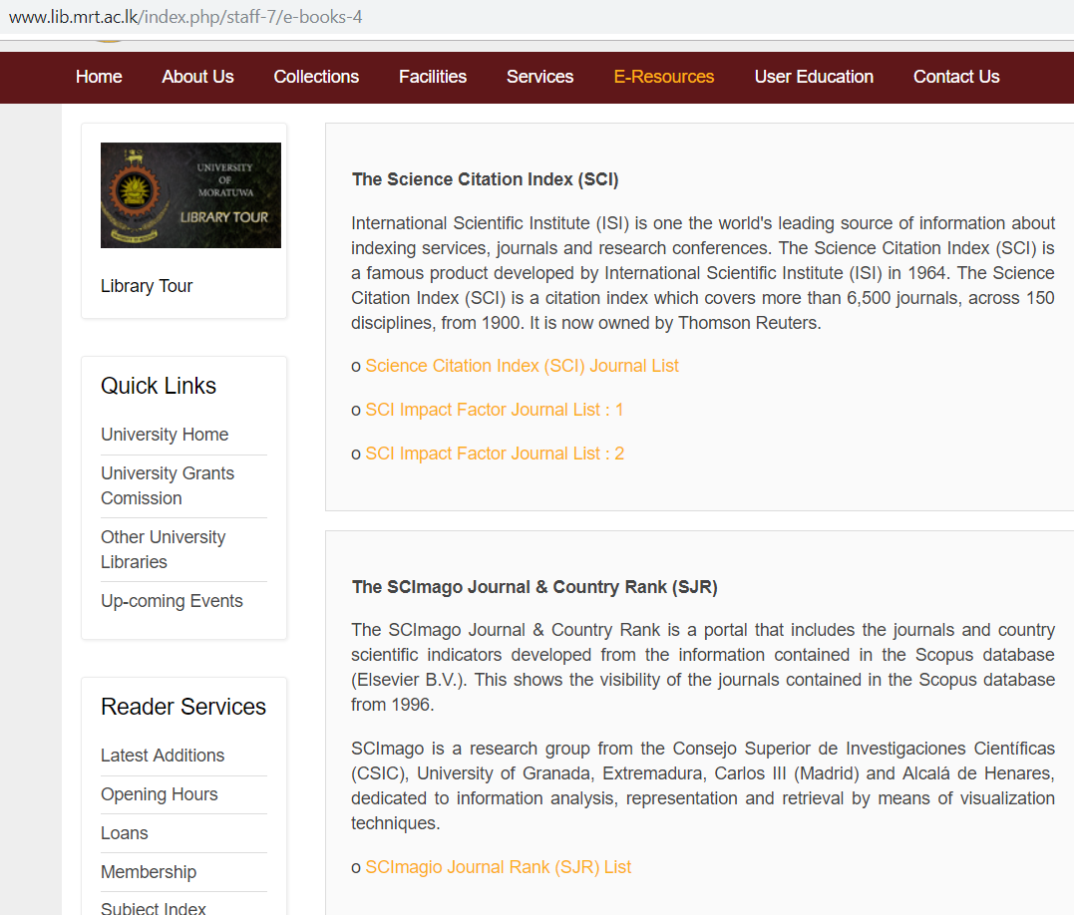

2) Perform “simple” search by typing the “title of the journal”.

3) If the journal is listed in SJR, click on “journal title”. Scroll down the webpage till you find whether journal is rated as Q1 or Q2.

Example 1

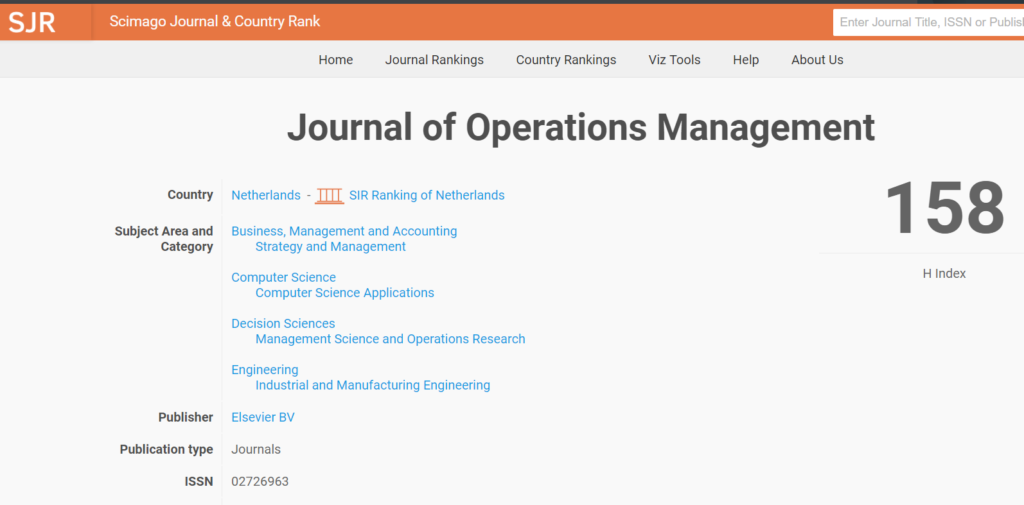

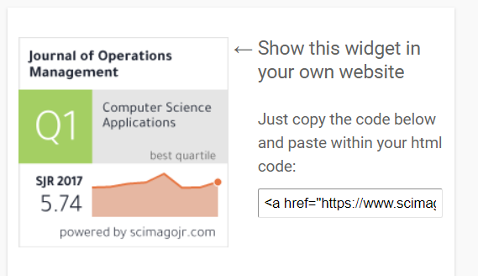

Example 2

